**Panasonic Lumix G 25mm f/1.7 ASPH. Lens**

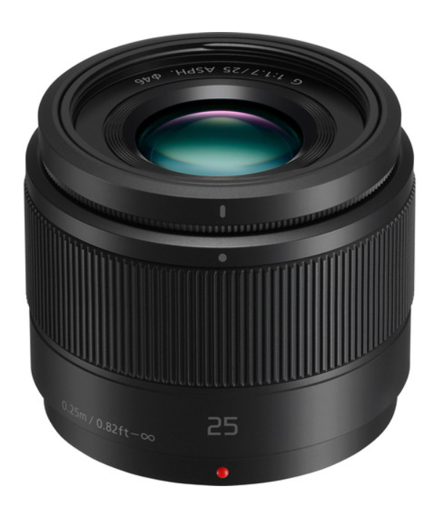**$147.99**

* Micro Four Thirds System Lens
* 50mm (35mm Equivalent)
* Aperture Range: f/1.7 to f/22
* One Ultra-High Refractive Index Element
* Two Aspherical Elements
* Nano Surface Coating
* Stepping AF Motor
* Rounded 7-Blade Diaphragm

*A fast, normal prime designed for Micro Four Thirds mirrorless cameras, the****Lumix G 25mm f/1.7 ASPH.****from****Panasonic****is a 50mm equivalent lens featuring a bright f/1.7 maximum aperture for enhanced low-light shooting and depth of field control. One UHR (Ultra-High Refractive Index) element pairs with two aspherical elements to reduce spherical aberrations and distortions for consistent edge-to-edge sharpness and illumination. A Nano Surface Coating has been applied, too, and helps to reduce flare and ghosting for increased contrast and color fidelity. The optical construction also helps to realize a compact overall form factor, measuring just 2"-long and weighing 4.4 oz. Benefitting both stills and video capture, this lens also incorporates a stepping motor for smooth, quiet autofocus performance that is compatible with Lumix cameras' high-speed contrast-detection focusing systems.*

Designed for Micro Four Thirds mirrorless cameras, this lens provides a 50mm equivalent focal length to represent a normal perspective.

Fast f/1.7 maximum aperture benefits working in difficult lighting conditions and also enables extensive control over focus placement for selective focus applications.

One UHR element and a pair of aspherical elements help to achieve even illumination and sharpness for consistent performance throughout the aperture range.

A Nano Surface Coating has been applied to individual elements to noticeably reduce lens flare and ghosting for greater contrast and color fidelity when working in strong lighting conditions.

Stepping motor delivers fast, smooth, and near-silent autofocus performance to benefit both still photograph and movie recording applications.

Rounded seven-blade diaphragm produces a smooth out-of-focus quality when working with shallow depth of field techniques.